Computer Language Coding Concepts

Interfaces
Up till now the idea of interfaces was fully left out of the stories. This chapter makes the concept of interfaces catch up with the rest of the documentation. The basic concept of interfaces is covered along with its diagram notation. Also covered are: interface assignment, interface reference and relations that form through the use of interfaces. Another concept, yet to be worked out, is how commands of an object are grouped by site: an object can have commands, defined on different sites, and the commands should be grouped by site in order to judge how reliable the commands are (Grouped by Source). As interfaces can be applied to objects, but interfaces can also be applied to commands.

At some point the idea was, to also cover all the different uses of interfaces. But the different uses of interfaces are adequately described by other literature. The focus will lie on explaining the raw concept of interfaces and their presence in the new computer language.

Author & Copyright: Jan-Joost van Zon Date: May 5, 2009 – May 7, 2010 Location: Oosterhout, The Netherlands Status: Finished

Interfaces Main Concepts
The main concepts of interfaces are explained here along with their diagram notations.

Interface = Publics
An object’s interface consists of all of its public members.

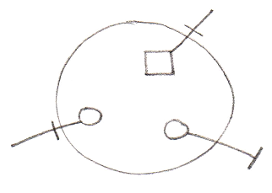

Interface & Implementation
An interface defines an object’s public members. The privates of an object are called the object’s implementation. So the concept of interfaces offers the ability to separate publics from privates, in other words separate interface from implementation.

Object:

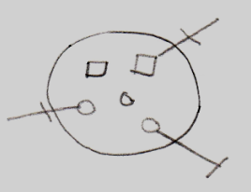

Interface:

Implementation:

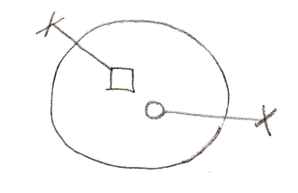

Interface = Objects Melting Together
Another concept which employs the word interfaces, is an object (an interface) melting together with its container.

This is displayed in the diagram by a triangle tht represents the interface object.

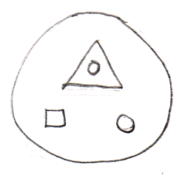

The members of the triangle are accessible as if they are members of the large circle.

Interface = Contract
Interfaces also offer the functionality of being a contract.
You can establish this by defining the interface externally.

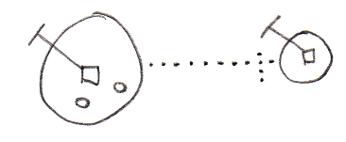

If an object has its interface defined externallly, the public contents of the object can not be freely changed. If the interface of the object needs to change, the externally defined interface needs to be changed.

Multiple Interfaces
If you want an object to support multiple contracts you can use several triangles inside the object and define their interfaces externally.

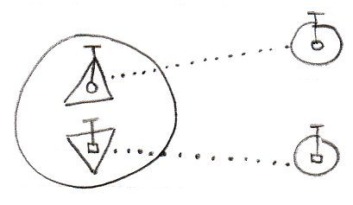

Interface Type Control
Interface type control should for instance occur when you reference an object and the reference has the wrong interface. Restrictions must then be enforced.

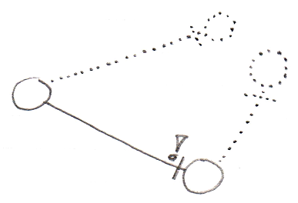

The situation above is not valid, because the reference does not have the same interface as the object it points to.

Explicit Interfaces
You can speak of an explicit interface when you externally define a sub-object’s interface, you but do not let the sub-object melt together with the container.

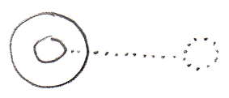

This requires you to refer to the interface directly in order to access it. A reference to the parent can not automatically resolve to a reference to the interface.

Implicit Interfaces
You can speak of an implicit interface when you externally define a sub-object’s interface, but you do let the sub-object melt together with the container.

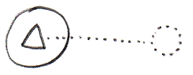

You can reference members of the interface directly through the circle, without explicitly mentioning which interface you are accessing (see Interface Object Resolution).

Polymorphism
A triangle’s difference with a circle is that triangles basically melt together with their container.

Next to all members of the triangle being accessible as if they were members of the parent circle, the container can also be referred to as if it has the type of the triangle. That is another effect of melting the objects together.

Interface Object Resolution / Polymorphism

Interface object resolution happens when you reference an object and the reference has an interface defined, that the object supports. It automatically redirects the reference to the specific interface of the object.

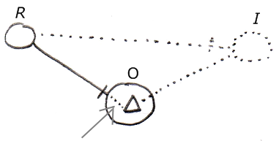

It is about the bit of dotted line denoted by the arrow. This is an automatic extension of the solid line on the left. Because the the reference (R) on the left has an externally defined interface (I) on the right, and the object (O) supports this interface, the reference’s line is automatically redirected to this particular interface of the object. Automatic redirections like that are called object resolution.

There are a lot of other object resolution concepts related to interfaces and inheritance, such as overriding and shadowing, but they will be covered separately in the Object Resolution chapter.

The situation above only works in case of implicit interfaces.

Below is another example of interface object resolution, but now in case of referencing a member of the interface, while not explicitly accessing the interface:

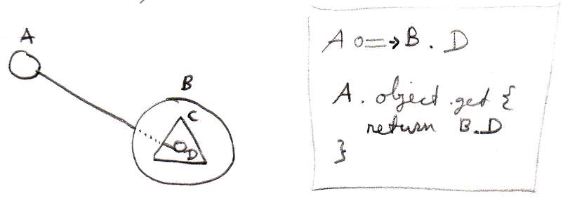

Again it is about the dotted piece of line in between, which expresses the automatic object resolution. Next to the picture is a bit of pseudo-code that expresses how reference A points to D without qualifying it with interface C.

Inheritance
Traditional inheritance is related to the concept of interfaces. What happens is that an object melts together with its container and next to its interface being defined externally, the implementation is also defined externally. The result is classic inheritance: one object takes over all characteristics of another object.

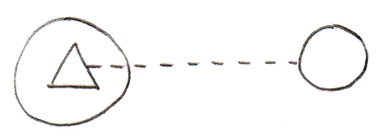

So because the triangle has an externally defined class (dashed line) instead of an externally defined interface (dotted line) the situation turns from implicit interface into classic inheritance. In the situation above one object inherits from another object. Expressing it more like one class inheriting from another class it would look as follows :

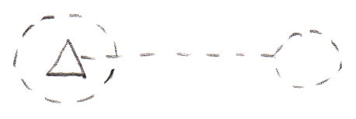

Classic inheritance is not the only form of inheritance in the new computer language. Different forms of inheritance are covered separately in the chapter Inheritance, but it is important to point out here, that classic inheritance and interfaces are closely related.

Main Usages of Contracts
When you externally define an interface, it becomes the concept of a contract. You can creatively use this concept for any purposes, but some of those purposes deserve to be pointed out explicitly.

It can be a contract of a guarantee to support a sure set of members. So this offers a guarantee to ones that will be using the object. So you know an object has at least those members with that exact configuration.

An interface can also serve as a contract of usage. So now someone using the object will only be able to use it in an exactly defined way. This means, that an object has exactly the members defined by the interface.

A powerful application of such a contract, is the interface as a contract of participation. You can give a type an already defined interface. That allows objects that can work with a certain interface, to link to objects of the new type, even when the system was not originally aware of that type. This concept makes it possible to introduce new types of objects into a system, that was not originally aware of them.

Interface Aspect
While systems seem to be composed of a lot of different types of objects, all objects and types are in reality no more than a very limited set of types, that can be configured to look like other types. Those basic objects are called system objects. The behavior of those system objects is controlled by controlling their system aspects. System objects is covered in a separate chapter called System Objects, but there the interface aspect was completely left out of the story. In this part of the documentation everything about the interface aspect is laid out to make the concept of interfaces catch up with the System Objects story.

The Interface aspect allows you to control how objects look on the outside, while the insides of the objects can differ completely.
Another concept which employs the word interfaces is an object (an interface) melting together with its container. From a systematic point of view they seem to be completely unrelated concepts, however in practice they are conjoinedly used. To distinguish them we call them the Interface aspect and the Interface Merging aspect. The main diagram symbolization of the Interface aspect is as follows:

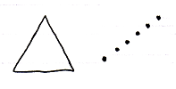

The triangle is the symbolization of the Interface Merging aspect, and the dotted line is the symbolization of Interface aspect.

Interface Merging will probably become an aspect that will extend beyond the concept of interfaces in the future, because it could for instance apply to the concept of default members.

System Commands for the Interface Aspect
The main system commands to control the Interface aspect are:

Use As Interface
Interface Set
Reference-Interface Set
Object-Interface Set

Use As Interface is like Object Get, but then for the purpose of using that object as the interface of another object. This is common usage of the interface aspect. It also makes you able to separately access control whether an object can be used as an interface.

The Interface Set command is executed on an object reference. The reference can then only point to object that supports the interface. This means either that the other object has the same interface, or that the object has it as sub-object that is an implicit interface. For now Interface Set applies only to references and not to objects, because the interface of an object can only be set upon creation. Perhaps in the future this rule will be broken, but for now that is the rule.

The commands Reference-Interface Get and Object-Interface Get get the interface object that is associated with a reference or object. Those commands are actually less commonly used.

Interface is both Object-Bound and Reference-Bound
The Interface aspect applies to both objects and references, but differently. An object has a certain interface, that is set upon creation and throughout its lifetime. A reference can also have an interface, defining which classes of object you can assign to the reference. The interfaces of an object can never change. The interface of a reference can be changed, but only to an interface supported by the object it points to or arbitrarily while the reference is Nothing.

Pointer-to-Pointer Situations
In a standard situation the Use As Interface, Interface Set, Reference-Interface Get and Object-Interface Get commands are about making an object function as another object’s interface. However, you can also make something’s interface be yet again another reference. That means that another parent object determines the eventual interface.

(However, this might create difficulty for the system to maintain an object’s constant interface. You might want another parent to determine the initial interface, but the interface of an object should not change during its lifetime.)

Set Interface to Reference
To be able to set the Interface aspect to another related item, Interface Set has two overloads:

Interface Set → Set Interface to Other Related Item.
Interface Set → Set Interface to Other Related List Item

If you want a single name to express both situations, you could call it Set Interface to Reference.

Get Interface which is a Reference
Because the Interface aspect can be set to another related item, the Interface Get command gets extra overloads. Next to that, there are different overloads for the two types of Interface Get: Reference-Interface Get and Object-Interface Get. This creates the following overloads:

Reference-Interface Get → Get Reference-Interface which is Another Related Item
Reference-Interface Get → Get Reference-Interface which is Another Related List Item

Object-Interface Get → Get Object-Interface which is Another Related Item
Object-Interface Get → Get Object-Interface which is Another Related List Item

You could also call them Get Interface which is a Reference.

Use Reference As Interface
The Reference aspect can be access-controlled for different ways you can use it. Pointer-to-pointer situations require you to be able to use a reference as an interface. To be able to access control the different purposes for which you can use a reference, the Reference Get command gets the secondary implementation:

Use Reference As Interface

which delegates directly to the Reference Get command.

The Overloads Recapitulated
Do not wreck your brain over all this delegation and overloading. It is just for pointer-to-pointer situations to have the same command names as standard situations, and also to be able to separately access-control the specific uses of references or objects. You will not usually see the pointer-related commands, because they will be implicitly delegated to by the main commands. This leaves us with the following commands:

Use As Interface
Interface Set
Reference-Interface Get
Object-Interface Get
Use Reference As Interface

Detail: For that last command you might want to overload Object Get. But that does not work. You can not overload it, because they will both take a pointer to an object as an argument. To disambiguate, they have to have a different name and you have to point to a specific command.

Commands for the Interface Merging Aspect
The commands for the Interface Merging aspect are:

Interface Merged Get
Interface Merged Set

Interface Merging is a reference-bound aspect: it only applies to references, not objects.

Interface Merged is a Boolean, that can be either True or False.

When an interface is merged it means that its members merge with its container and are accessible as if part of the container. Also, the container can be referenced as if it has the type of the interface.

Interface Aspect in System Interface
System aspects can be shown in the system interface notation as worked out in the System Interfaces articles in the System Objects chapter. The Interface aspect was not covered there, so this is a supplement to that documentation, covering it for the Interface aspect.

Object-Interface Aspect in System Interface of Object
The Interface aspect has five system commands, but only two of them apply to Objects. The other ones apply to references. The Interface aspect of an Object is controlled through the following commands:

Use As Interface
Object-Interface Get

The commands are placed inside the system interface inside a triangle that wraps together the members of the Interface aspect:

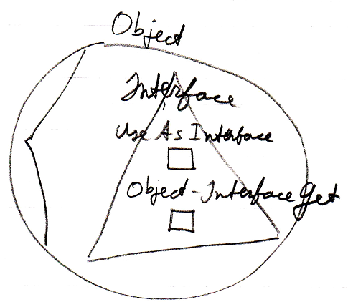

Reference-Interface Aspect in System Interface of Related (List) Item
The interface aspect has five system commands, but only three of them apply to Related Items:

Inteface Set
Reference-Interface Get
Use Reference As Interface

The commands are placed inside a triangle, that wraps together the members of the Interface aspect:

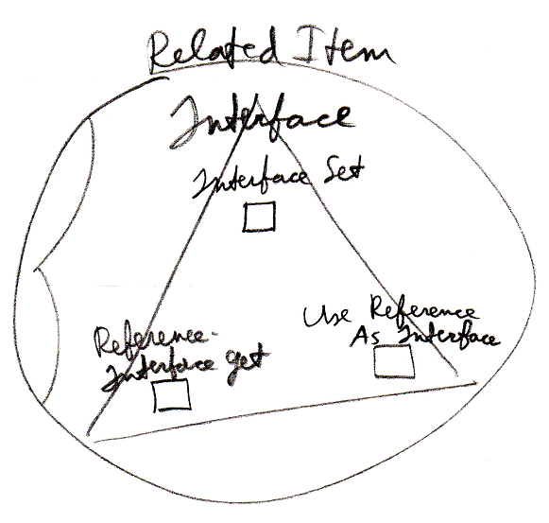

It works the same for a Related List Item as it does for a Related Item.

Reference-Interface Aspect in System Interface of Related List
A list can centrally control the aspects of its items. Therefore, a list can control the Interface aspect of its items, centrally setting the Interface that all the items must support.

The system commands to do this are placed inside a triangle that wraps together the members to control the Interface aspect:

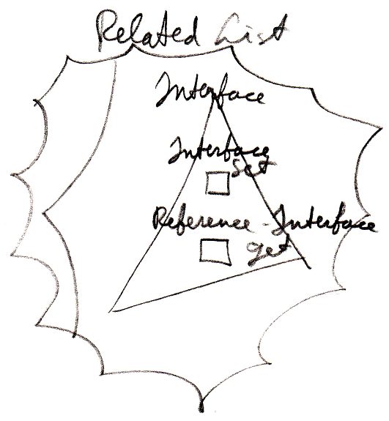

The Use Reference As Interface command is not present, because that command does not apply to the list as a whole, but only to a particular item in the list.

Interface Merging Aspect in System Interface of Related Item
The Interface Merging aspect only applies to Related Items. It is controlled through two commands:

Interface Merged Get
Interface Merged Set

The commands are placed inside the system interface inside a triangle, that wraps together the members of the Interface Merging aspect:

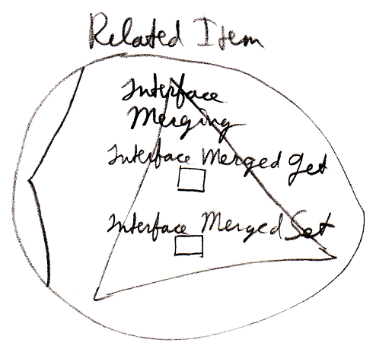

Interface Merging does not apply to Related List Items, because it does not seem to be practical there.

Interface Assignment Types
This section is a mere supplement to the Assignment articles in the System Objects chapter. For a general explanation of assignment, look there. This section only makes the Interface aspect catch up with the rest of the explanations.

Interface Assignment
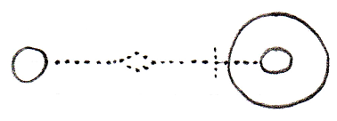
Use As Interface ← (~= Object Get)
Interface Set →
Makes the source become
the interface for the target.
Interface Pointer Assignment
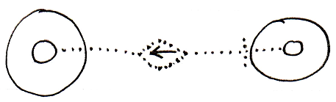
Use Reference As Interface ← (~= Reference Get)
Interface Set → (~= Set Interface to Other Related Item)
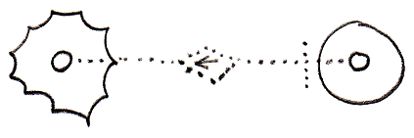
Use Reference As Interface ← (~= Reference Get)
Interface Set → (~= Set Interface to Other Related List Item)
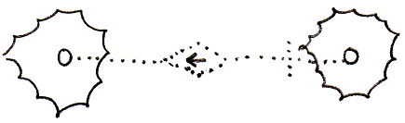
Use Reference As Interface ← (~= Reference Get)
Interface Set → (~= Set Interface to Other Related List Item)
Interface Assignment With Pointer Source
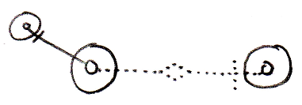
Use As Interface ← (~= Use Reference As Interface)
Interface Set → (~= Set Interface to Other Related Item)
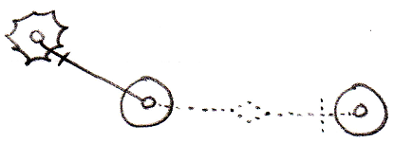
Use As Interface ← (~= Use Reference As Interface)
Interface Set → (~= Set Interface to Other Related List Item)
Cross-Aspect Interface Assignment
Object-Interface to Object Assignment
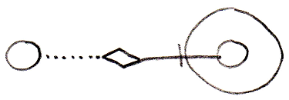
Object-Interface Get ←
Object Set →
Reference-Interface to Object Assignment
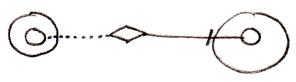
Reference-Interface Get ←
Object Set →
Object-Interface to Reference-Class Assignment
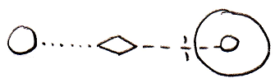
Object-Interface Get ←
Reference-Class Set →
Object-Class to Reference-Interface Assignment
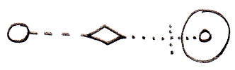
Object-Class Get ←
Reference-Interface Set →
Reference-Class to Reference-Interface Assignment
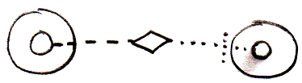
Reference-Class Get ←
Reference-Interface Set →

There are more implementations of the cross-aspect assignments for cases when the source of the assignment is a pointer-to-pointer, but they are not shown here. To understand the concept look in the Cross-Aspect Assignments article in the System Objects chapter.

Interface - System Command Call Notations
The concepts of system command call notations is not explained here. Refer to the System Command Call Notations article in the System Objects chapter for that. this is a supplement to that documentation, covering it for the Interface aspect. The Interface Merged aspect is also covered.

Cross-aspect situations can apply to the Interface aspect, but they are not covered. Cross-aspect situations between the Object and Class aspects are described in the System Objects chapter and adequately shed light on the topic.

Interface – System Interface - Command Call Notation
Only one example of a call to a system command of the Interface aspect using the system interface notation will be given here. Below you will find this notation for a call to the Object-Interface Get command:

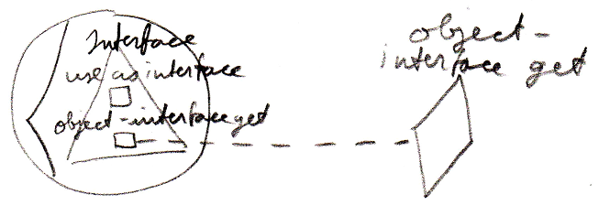

Interface – Simplified System Command Call Notation
Below you will find the various types of calls to a system command on the Interface aspect in the simplified system command call notation.

Use As Interface | Use Reference As Interface
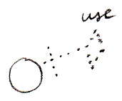 | 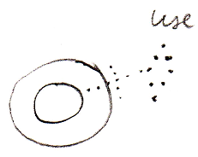
Interface Set
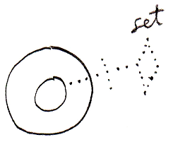
Object-Interface Get | Reference-Interface Get
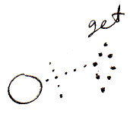 | 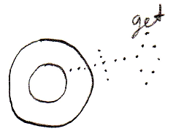
Interface Merged Get | Interface Merged Set
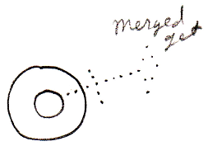 | 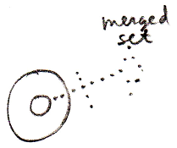

Interface – System Command Call Notation with Argument
Below you will find the various types of calls to a system command on the Interface aspect in the system command call with argument notation.

Use As Interface | Use Reference As Interface | Interface Set
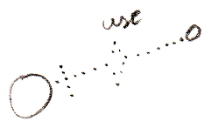 | 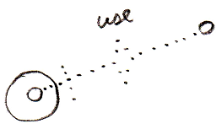 | 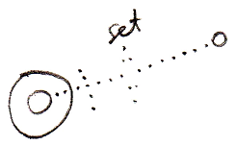
Use As Interface ←  (Interface Set →) | Use Reference As Interface ←  (Interface Set →) | (Interface Get →)  Interface Set ←
Object-Interface Get | Reference-Interface Get
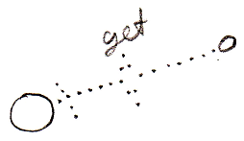 | 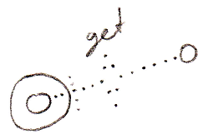
Object-Interface Get ←  (Interface Set →) | Reference-Interface Get ←  (Interface Set →)

Interface Merged Get | Interface Merged Set
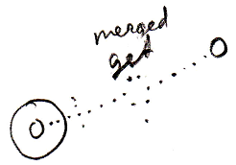 | 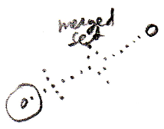
Interface Merged Get ←  (Value Set →) | (Value Get →)  Interface Merged Set ←

(For the Interface Merged commands the argument is a Boolean.)

Interface – Explicit Get & Set Notation
Below you will find some examples of the explicit Get and Set notation working on the Interface aspect.

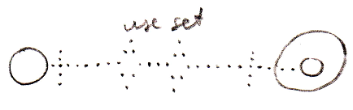

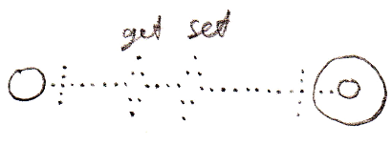

Interface – Explicit Get & Set Arguments Notation
Below you find various notations where Get and Set arguments are explicitly drawn out, where the Interface aspect is adressed.

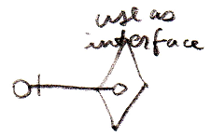

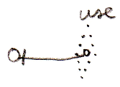

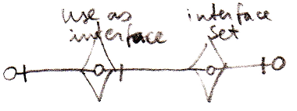

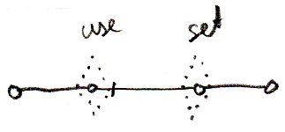

Interface Connectors
Below you will find an overview of the possible connectors concerning the Interface aspect and the Interface Merged aspect.

Use As Interface | Use Reference As Interface
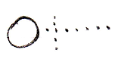 | 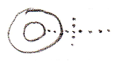
Interface Set
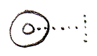
Object-Interface Get | Reference-Interface Get
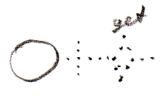 | 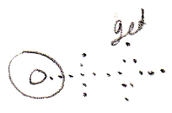
Interface Merged Get | Interface Merged Set
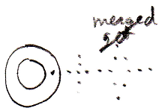 | 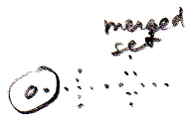

Interface Connections
Below you will find the possible connections for the Interface aspect and the Interface Merged aspect. A connector is a result of a call to a system command. However, the result of call to the Interface Merged Set command is that the reference becomes a triangle or a circle shape. This result is also presented in the overview.

Use As Interface | Interface Set
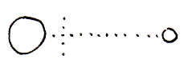 | 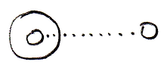
Interface Merged = True |  | Interface Merged = False
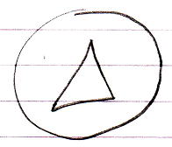 |  | 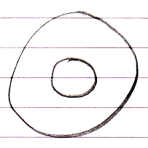

New with Interface Parameter
The New command was introduced in the System Objects chapter, having an optional Class parameter:

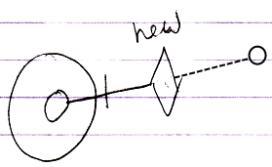

But not, an Interface can be specified upon creation of an object as well. This gives the New command an extra implementation:

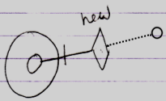

Now the New command’s Interface parameter is filled in. The new object will have a fixed interface, but the object does not have a class. Its Publics are fixed by the interface, but an implementation is free to fill in.

You do not need to set both Class and Interface parameter of the New method, because if the Class parameter is set, it determines the Interface too.

Reliability of Interfaces
An interface is a contract. A welcome fact about a contract is that once agreed upon, it does not change. So an interface should be reliable.

However, in the new computer language the concept of relations can make interfaces unreliable.

Relations are bidirectional. When something points to something else, the other thing points back. This causes extra members to be dynamically added to the interface of another object. The interface of one object changes when other objects start pointing to it.

So get rid of backward relations? No. The benefits from bidirectional relations are too important. They solve a difficult fundamental problem in computer technology. A lot of times you want to know whether an object is still used and what specifically still uses this object. In computer systems today this is often difficult to find out. Knowing all backward connections all the time would solve this problem.

Another concept that springs to life by employing bidirectional relations is the neat phenomenon, that when a command has parameters, the command is immediately available from any object that the command could be executed on.

To keep interfaces reliable, backward relations should not automatically become part of the interface. The solution is to make the backward relations Private. This disincludes the members from the interface, and only makes them part of the implementation.

Other options have been proposed to responsibly get rid of the automatically created members. All the options will be explained now.

Backward relation options:

- Private
- Public
- Manual
- Conditional
- Preliminary

Private backward relation

Allowing backward relations but making them Private means the backward relations are maintained, but they do not become part of the interface.

Public backward relation

Allowing Public backward relations means the interface will not be stable, because extra members are created when things start pointing to an object.

Manual backward relations

In this case backward relations are not created automatically. Logically this keeps the interface stable. You can program the backward relation later, but only if you know where the foreward relation is. To find all foreward relations them all you may just need to scan the entire earth, so it is not easy.
When you are able to program the relation back, you also need permission from the foreward relation, because this could have great implications on the way the other object functions.

Maintaining a backward relation should be strongly stimulated because it solves such a difficult fundamental problem in computer technology. To equally honor the values of both the interface concept and the relations concept, the default solution should be to make backward relations Private. Keeping backward relations Private keeps interfaces stable.

Now follow some other solutions, that are sort of arbitrary and miscellaneous, but possibly handy in practice.

Conditional backward relations

Perhaps you should automatically accept backward relations based on a condition, for instance that the relation counterpart is within the same module.
It may be a neat editing feature. That way you can program a module and let backward relations build up, but outside sources can not influence this process. This limits control to interface extensions to the module itself. In a broader sense you are defining a condition for automatically accepting a backward relation: namely that the relation counterpart must be inside the same module.

Preliminary backward relation

Preliminary backward relation means that the foreward end of the relation will maintain the backward relation until the relation counterpart either accepts or refuses it. This politely keeps the other related object’s interface and storage in tact while still offering the ability to adopt the index. You may also solve a quota overrun security problem this way.

This sounds good in theory, but in practice it may turn out that the registration of the request takes the same amount of storage as storing the backwards relation itself.

Imaginary Backward Relations
Sometimes when a backward relation is not stored, you want to see it anyway. Particularly: you always want to see all available commands inside an object. Even though an object does not physically have a reference to all the commands, you want them all available inside the object anyway.

This requires backward relations that are not stored, to be shown anyway.
The solution is to draw them out as imaginary backward relations.
This requires some recalculation whenever the view changes.
But this is only done for related commands and objects inside modules that you actively reference.
You still will not have all possible commands on the internet available inside the object, but you do not want that anyway, because that would be a ridiculous amount of commands. You just want the ones from sites that you are aquainted with.

Command Interfaces
This article is here to point out that commands can have interfaces just like objects. A command having an interface approximates the same functionality as C++ function prototypes or delegates in .NET. Only in the new computer language it much more is possible. Because a command is an object, any interface concept is applicable to commands as well.

Here is your basic function prototype concept expressed in a new computer language diagram:

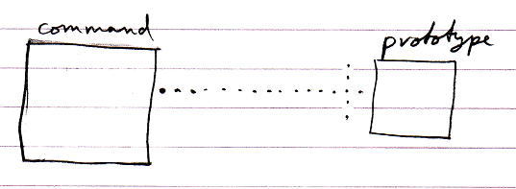

Here is the example when the command has a paramater.

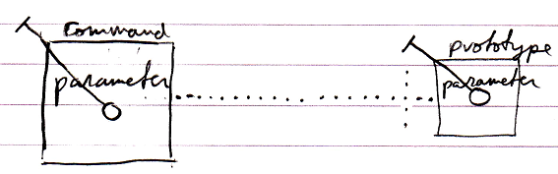

The implementation of the command can be different from its function prototype:

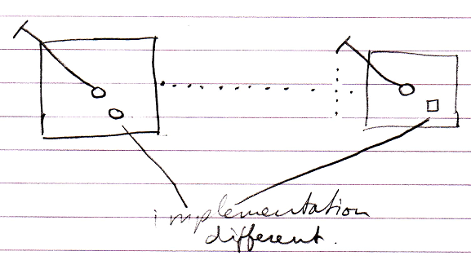

But this was classic C++ function prototype. The new computer language has more possibilities when it comes to command interfaces, some of which are displayed below.

Command inheritance:

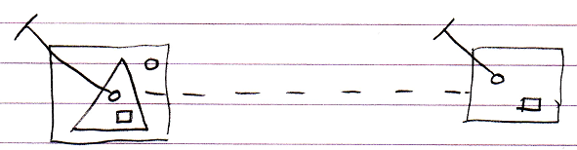

Multiple command interfaces:

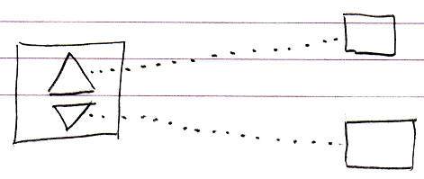

So basically anything regarding interfaces that can be done with objects, can also be done with commands.

Member Grouping
Triangles could be used to indicate a benign member grouping:

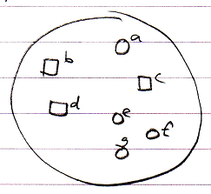 | → | 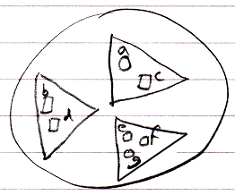

Because a triangle basically merges with its container, it’s like you aren’t bothered by the borders of a triangle.

At first glance the grouping does not seem to affect how the objects are used. However, two problems arise:

- Explicit interface dependency
- Call overhead

Below these two problems are explained and possible solutions are given. Solutions for these problems are still very much open to discussion.

Explicit interface dependency

Existing functionality may not be affected by member groupings. However, you could make new connections directly to the new interface objects.

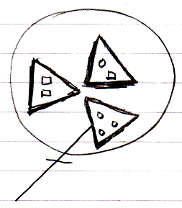

The new connections are now dependent on the member grouping, which was only meant to be a loose definition.

To allow member grouping to be benign, some solution must be found for this. The solution probably lies in the area of access controlling system commands. The member groupings need to be access controlled enough to not be able to explicitly connect to them, but not so much that it makes their members totally inaccessible. Separately access controlling Get For Access and Get For Copy might solve this problem. However, it needs to be thought through if this really only blocks something’s usage as a qualifier. If it does not, probably another split up in system commands will do the trick.

Ideas about the separation between Get For Access and Get For Copy can also be found in the Black Box chapter and the System Objects chapter.

Call overhead

Member grouping may seem benign, but when you approach a member of a group, an Object Get command on the group must be executed before accessing the member, which causes (a small) processing overhead on the call.

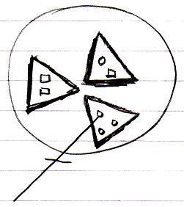

The solution could either lie in optimization, or making the triangles imaginary.

Imaginary elements of a diagram were introduced in the Automatic Containment article. Making the member groupings imaginary might be a bad idea, because up until now imaginary elements of the diagram were calculated by the system, and not set by a programmer and it might be wise to keep it that way.

A better solution may lie in optimization. Programmers often add structure to their programs even though it is not absolutely necessary, but just makes things more tangable and orderly. Taking such structurings out of a program before it is run, is more of an optimization issue than anything else.

Interface Referencing and Redirectioning
This article contains examples of what diferent interface referencing and redirectioning situations would look like in a diagram and what name we could give to this situation.

Interface Reference

An object’s specification of which interface it has, is also called an interface reference.

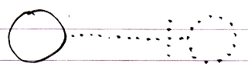

Command Class Interface

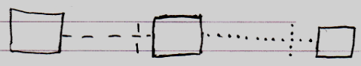

Class Command Interface

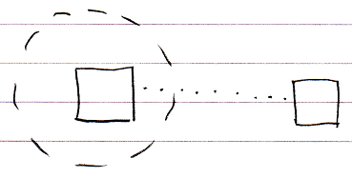

Command Definition Interface Redirection

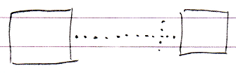

Command Reference Interface Redirection

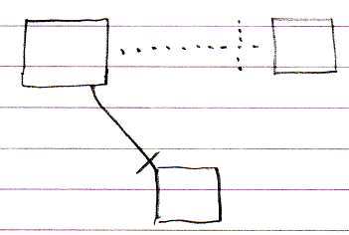

Command Call Interface Redirection

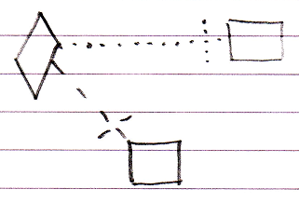

Active Clause Interface Redirection

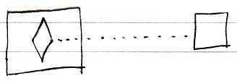

Inactive Clause Interface Redirection

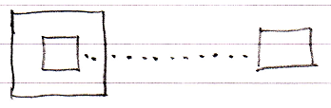

Target Interface
The target interface is found by following a number of redirections to find the actual interface object that the publics of an object are based on.

To find the target interface, you first follow all the object redirections, then a maximum of one class redirection, then all the object redirections again, then a maximum of one interface redirection and then all object redirections again, and there it ends.

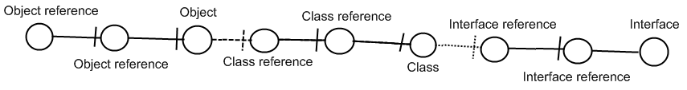

Here is an example where there are no class lines involved:

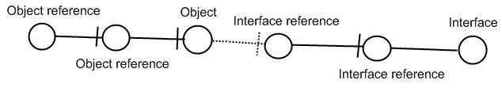

If the interface has an interface as well, this does not redirect the original object’s interface, because the second interface is another interface object, that the first interface is just based on. An object redirection is just a much tighter bond, than a class or interface redirection.

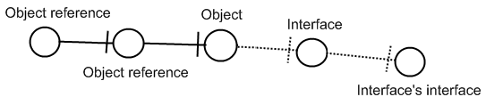

The target interface of the object reference is the symbol Interface, not the symbol Interface’s interface. So you should not follow more than one interface redirection to get to the interface object.

You should also not follow more than one class redirection to find the target interface. If the class has again a class which has an interface, the first class does not have an interface defined at all:

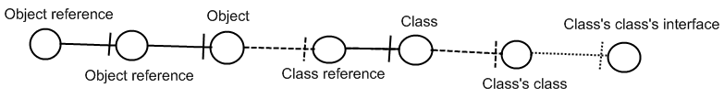

The last symbol Class’s class’s interface is only the interface of Class’s class, not the interface of Class. So Class is where the interface redirections end.

Also, you should follow one class redirection and one interface redirection in that order. Here is a less logical example, in case of which you do not follow the last class redirection:

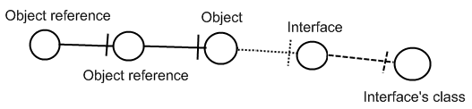

The last symbol may eventually define the interface, but it is still Interface which is the Object reference’s interface object.

Relations Though Interfaces
The most fundamental relation is a relation between two objects: one object contains a reference to another object, and the other object contains a reference back to the first object.

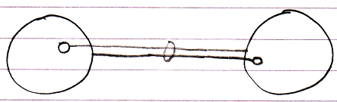

Classes can put control on which other class they are related to.

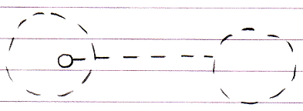

The effect is that in an object of that class, a specific reference can only point to an object of a specific other class.

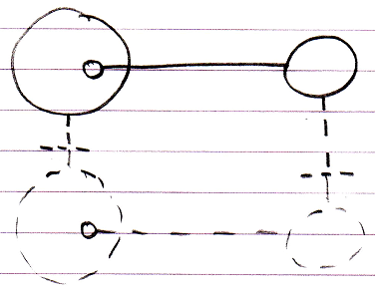

This is merely type re-enforcement. The picture below shows the classes in a bidirectional relation.

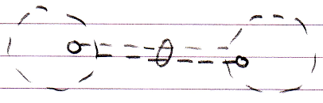

The example above illustrates what we call a relation between two classes. This relation between classes can be ‘felt’ throughout the object structure and is ultimately defined inside the classes.

Relations through interfaces is the same concept but now applied to interfaces. There are two possibilities.

The first possibility is that a class defines the interface of one of its references.

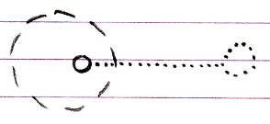

In that case it is said to be a relation between a class and an interface.
An interface can very well have a relation back to the class.

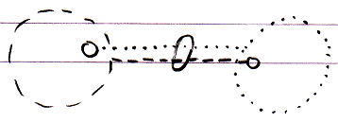

The effect of it is that objects that have that class or interface can only refer to an object of that a specific interface or class.

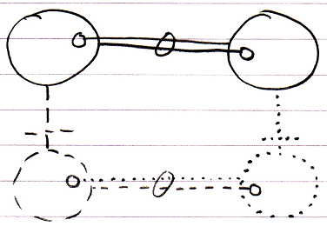

The second possibility is that an interface defines the interface of one of its references. And the other interface defines the relation back.

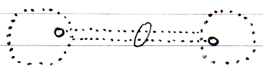

In that case it is said to be a relation between two interfaces. The effect of that is, that in objects with that interface, a specific public reference can only point to an object with that specific other interface.

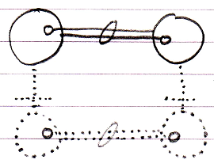

That is all there is to it. Relations between classes and interfaces are shear type-control on the relations between objects. Also, the mutual references are kept in sync, so that the two references always mutually point to eachother and not to anything else (that’s what the ring is for).

Group By Source
Your class can automatically be extended with extra commands from other sites, if you allow other sites to form bidirectional relations with your class.

The following foreward relation:

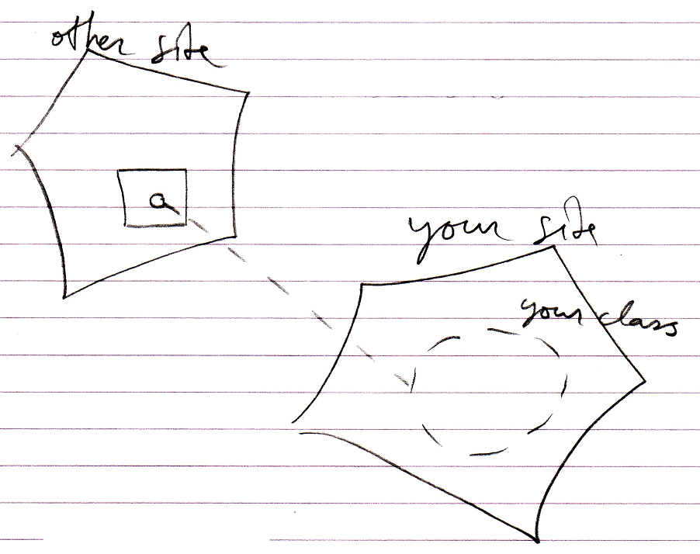

Can add a backward relation:

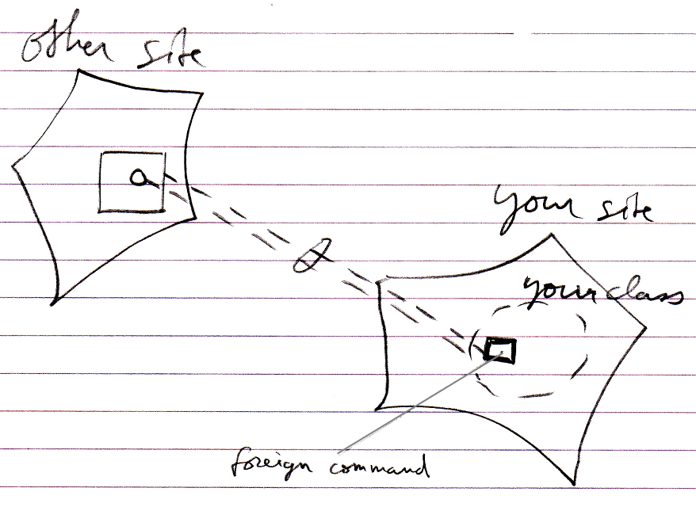

This creates an extra command inside your class, that is defined on another site.

The danger arises, that your class gets extended with commands that are not from a reliable source. To battle this danger a mechanism of control may need to be imposed.

The group by source concept is such a mechanism. Group by source introduces imaginary interfaces that group related objects by the site.

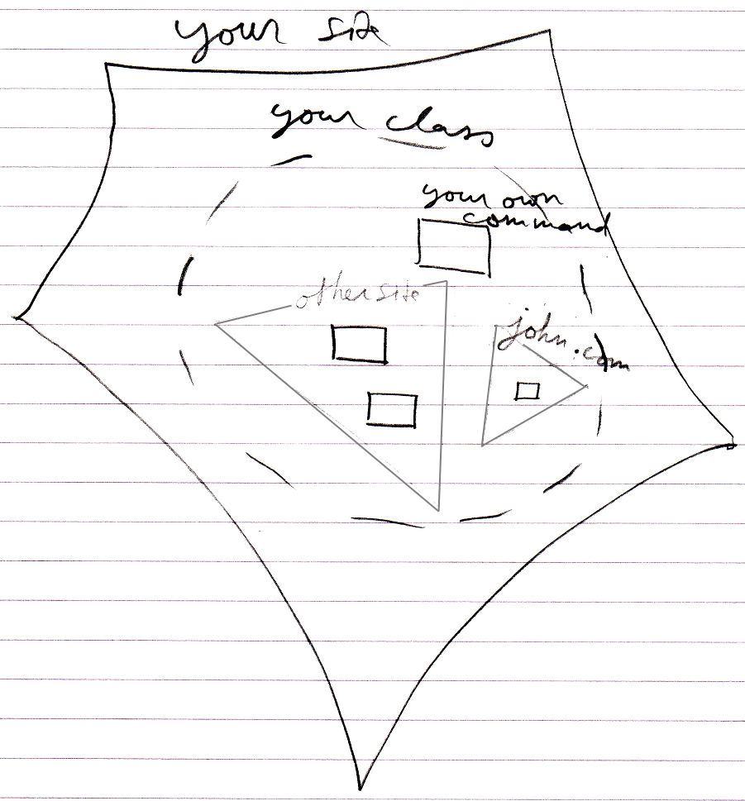

This means you get to see which site commands are defined on.

If you use a command from a vague site, then the command is not reliable. If you access a command through a class, and that command is hosted elsewhere, you have to know you can trust that other site.

You have to be aware of what site a command is from and estimate if your consider this site reliable before you run a command. You have to do with the whole internet now, so you have to be aware of where stuff comes. This counts for everything: commands, classes, objects, modules. You just need to be aware what site you are accessing and whether you consider it a safe source.

Other Thoughts
Perhaps the concept of group by source can be inspiration for grouping by other sources than site, like group by module for instance.

It does not need to be a site, that is the logical residence of a command; the logical residence of a command theoretically could also be an object. Each object, that locally defines commands for a class, could create a separate interface for that class.

Imaginary interfaces seemingly bring more stability to interfaces. Imaginary interfaces are author-bound, so one clumsy author can not mess up an interface authored by the one that authored the class himself. However, do remember that the real protection to a volatile interface is making backwards relations private or not automatically establishing backward relations at all.

A command can only be reliable, really, when the people authoring and using the command have a clear agreement about it. That is no different in other systems. Somebody hosting a web service could very well change the interface of the service, and have software, dependent on that service, crash. The only reason that wouldn’t happen, is because people have an agreement with eachother, not to change the interface just like that. And at times it does change unannounced, it really means systems will have problems.
Even interfaces of components on your local machine are only stable because of the agreement between you and the producer of the component. If they decided to automatically update the component, the interface or behavior of the component may very well change, and this may cause problems for your software. When it doesn’t, than this is because of the agreement, that you have with the other party.

Perhaps this concept can also be inspiration for being able to a apply a custom imaginary grouping for other analysis purposes.

An alternative to group by source is be to give things a different color in diagrams and in text code, depending on what site things are coming from.

Mutual Commands, Mutual Interfaces (Unfinished)
<

Brainstorm 2010-05-06

The idea described here is not what I want in practice. However, perhaps some derived concept could prove its use.

Perhaps you should be able to define some sort of generic interface.
If you define an interface with a command in it, that has a certain class, perhaps with some sort of mechanism or construct you should be able to reference any object that has a command with that class. You will get in trouble if an object has two commands with the same class, though.

One of the ideas behind this is idea is that objects, that have the same command, because they are both parameters of the command, have a joint interface, to create a relation. But really, they already have a relation, just an indirect relation, which is also a relation.

This idea just does not work. It only works if you assume that a command definition is unchangeable and that class references to the same command actually have to be the same procedure, but it hasn’t. You have have a command referenced twice that has elements to it that can still be redefined. Some part of the procedure could be data, that is part of the interface, so changeable.
When this would no be the case then yes an idea like objects with the same command have a mutual interface could work, but in dynamic circumstances that are possible in the new computer language I just want to forget about it.

>

A command is an interface
If multiple classes can support the same command, then the classes support the same interface: an interface that has only one command. The interface is represented by the command itself. Each command implicitly creates an interface. That is how it is expressed in a diagram too: a command implicity creates an interface.

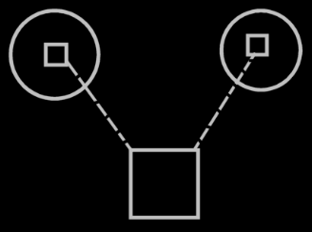

You don’t see triangles around the commands inside the circles, that would specify, that it is a separate interface: each command automatically becomes a separate interface. Just like each object also defines an interface; even though there is no triangle directly inside it, it still has an interface.

Multiple classes can support the same command
As you could see in the previous section: multiple classes, that support the same command, also support the same interface. Multiple classes supporting the same commands logically seems to create overlap in interface, but it doesn’t look like overlap in the diagram.

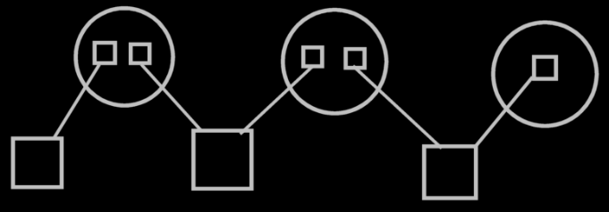

There are just multiple imaginary interface definitions (the circles), that each reference a different set of commands.
So a class referencing multiple commands, referenced by multiple classes, creates a visible interfaces of the class. The visible display of this interface is there, when you display the commands as part of a class, and not when you display the classes as parameters of the commands.

Extensive classification with interfaces (Unfinished)
Extensive classification through interfaces is about automatic definition of interfaces, as well as manual definition of interfaces. (Consider the imaginary group-by-source interfaces, which could be suggestions for interfaces to form). There may be more automatic definitions of interfaces, than just the one concerned with commands & classes loosely coupled, but this will be discussed in Extensive classification through interfaces.

Perhaps there will be other ways interfaces will be automatically defined.
Such as mutuality of commands creates mutuality of interfaces,

Groeperingssymbool op basis van wat een client object gebruikt. De interface indeling is op die manier een beetje automatisch. <2010-05-07 Move this idea to extensive classification through interfaces.> Als je geen interface indeling hebt, dan kun je toch zien wat de verschillende clients gebruiken en misschien voor het overzicht toch een interface indeling gebruiken.

Ideas

The texts below are loose ideas yet to be turned into good documentation.

The interfaces an object supports are interesting. It’s also interesting to know if an interface is supported by an object. Ofcourse you could derive that from the first data, but that’s not the fastest.

You should be able to group symbols inside a special symbol that controls the access for all the directly contained symbols. <2010-05-07 Just use a triangle and access control the triangle.>

